E-COMMERCE ORDER MANAGEMENT DATABASE SYSTEM

2. CATEGORY & PRODUCT TABLE DESIGN

1. Category Table
The Category table is designed to store and maintain the details of different product categories in the E-Commerce Order Management Database System. Each attribute is assigned a suitable data type and constraint for proper storage of category information.
S.No | Field Name | Data Type | Constraint | Description
1 | Category_ID | INT | PRIMARY KEY, AUTO_INCREMENT | Identifies each category record uniquely
2 | Category_Name | VARCHAR(50) | UNIQUE, NOT NULL | Stores the name of the product category
3 | Description | VARCHAR(200) | — | Stores a short description of the category

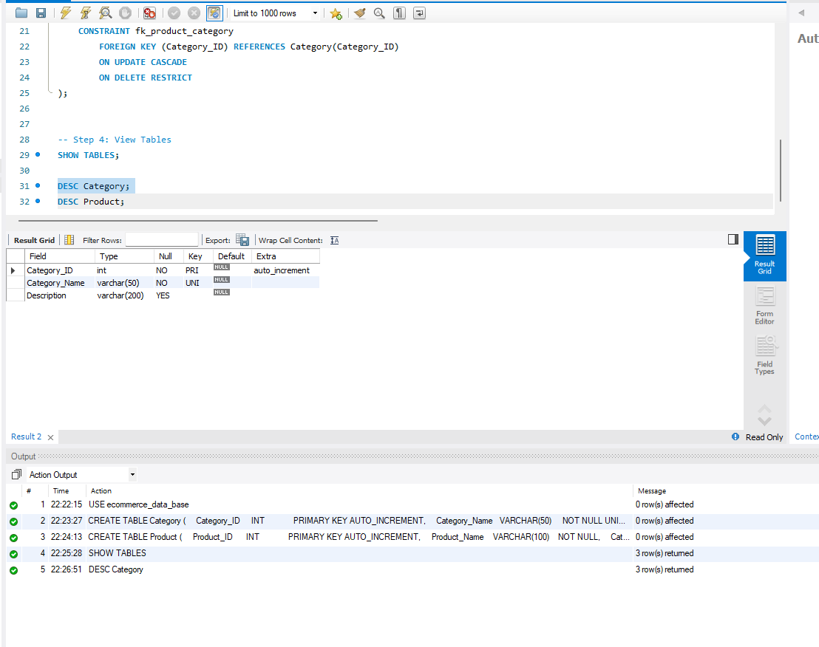

2. Product Table
The Product table is designed to store and maintain the details of products available under different categories. Each attribute is assigned a suitable data type and constraint for proper storage of product information.
S.No | Field Name | Data Type | Constraint | Description
1 | Product_ID | INT | PRIMARY KEY, AUTO_INCREMENT | Identifies each product record uniquely
2 | Product_Name | VARCHAR(100) | NOT NULL | Stores the name of the product
3 | Category_ID | INT | FOREIGN KEY, NOT NULL | Connects the product with its category
4 | Price | DECIMAL(10,2) | NOT NULL, CHECK | Stores the price of the product
5 | Stock_Quantity | INT | NOT NULL, DEFAULT 0, CHECK | Stores the available quantity of the product

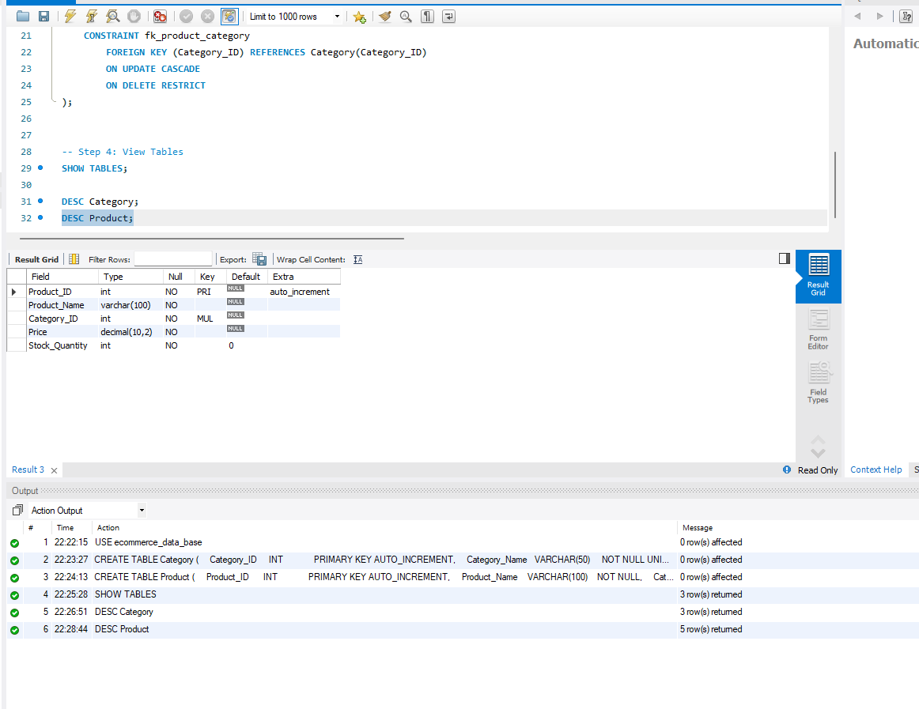

3. Attribute Description
Category_ID: Serves as the unique identifier for each category stored in the database.
Category_Name: Contains the name of the product category.
Description: Provides brief information about the category.
Product_ID: Serves as the unique identifier for each product stored in the database.
Product_Name: Contains the name of the product available in the system.
Category_ID: Connects each product to its corresponding category.
Price: Records the selling price of the product.
Stock_Quantity: Records the number of products currently available in stock.

4. Constraints
- PRIMARY KEY: Category_ID and Product_ID are used to uniquely identify each category and product record.
- AUTO_INCREMENT: Automatically generates a new ID for each category and product.
- NOT NULL: Ensures that important category and product information is entered.
- UNIQUE: Prevents duplicate category names.
- FOREIGN KEY: Category_ID in the Product table refers to Category_ID in the Category table.
- CHECK: Ensures that the product price is greater than 0 and stock quantity is not negative.
- DEFAULT: Stock_Quantity is set to 0 when no value is provided.

5. Conclusion
The Category and Product tables provide the required structure for storing product and category information in the database. The defined attributes, data types, relationships, and constraints help maintain the records in an organized and consistent manner.

